**PROJECT REPORT**

**INDEX**

**INDEX 1**

**LIST OF FIGURES 2**

**CHAPTER-1**

**INTRODUCTION 4**

**1.1 MOTIVATION 6**

**1.2 PROPOSED SYSTEM 8**

**CHAPTER-2**

**LITERATURE SURVEY 10**

**2.1 RELATED RESEARCH ON VEHICLE CLASSIFICATION 10**

**2.2 COMPARISION OF SYSTEMS 13**

**CHAPTER-3**

**BLOCK DIAGRAM AND ITS DESCRIPTION 14**

**3.1 SYSTEM DESCRIPTION 14**

**3.1.1 BLOCK DIAGRAM 15**

**3.2 HARDWARE INTERFACING 16**

**3.3 SPECIFICATIONS OF THE PROJECT 17**

**3.3.1FUNCTIONALITY 17**

**3.3.2 TOLL RATES 18**

**CHAPTER-4**

**HARDWARE AND SOFTWARE DESCRIPTION 18**

**4.1 PIEZOELECTRIC SENSORS 19**

**4.2 ARDUINO UNO 20**

**4.2.1 ARDUINO UNO SPECIFICATIONS 21**

**4.3 RADIO FREQUENCY IDENTIFICATION 23**

**4.4 USB UART 25**

**4.5 SOFTWARE DESCRIPTION [LABVIEW] 26**

**4.5.1 FRONT PANEL 27**

**4.5.2 BLOCK DIAGRAM 28**

**4.5.3 CONTROLS AND FUNCTIONS PALETTES 28**

**4.5.4 LOOPS AND STRUCTURES 29**

**4.5.5 VISA PALETTE 30**

**4.5.6 LABVIEW INTERFACE FOR ARDUINO 30**

**4.5.7 SOFTWARE PROGRAM AND DESCRIPTION 31**

**CHAPTER-6**

**FUTURE WORK 36**

**CHAPTER-7**

**CONCLUSION 37**

**CHAPTER-8**

**REFERENCES 38**

**LIST OF FIGURES**

**FIG 1.1** BLOCKS DIAGRAM OF VEHICLE CLASSIFICATION USING PIEZOELECTRIC SENSORS Page 15

**FIG 1.2** HARDWARE DESCRIPTION OF THE PROJECT Page 16

**FIG 3.3.2** TOLL RATES Page18

**FIG-4.1** PIEZO ELECTRIC SENSOR WORKING Page 19

**FIG-4.2** WORKING OF PIEZOELECTRIC CRYSTAL Page 20

**FIG 4.3** ARDUINO UNO MODULE Page 23

**FIG-4.4**  RFID READER Page 24

**FIG-4.5**  RFID TAG Page 24

**FIG 4.6** USB UART TTL MODULE Page 26

**FIG-4.7** LabVIEW FRONT PANEL Page 27

**FIG-4.8**  LabVIEW BLOCK DIAGRAM Page 28

**FIG-4.9** CONTROL AND FUNCTIONS PALETTES IN LABVIEW Page 29

**FIG-4.10** WHILE LOOP AND CASE STRUCTURE Page 30

**FIG 4.11** BLOCK DIAGRAM OF THE PROJECT Page 31

**FIG 4.12.1** FRONT PANEL OF THE PROJECT Page 32

**FIG 4.12.4** MESSAGE RECEIVING THROUGH MAIL Page 34

**FIG 4.12.1** FRONT PANEL DURING VIOLATION Page 35

**ELECTRONIC TOLL COLLECTION USING PIEZOELECTRIC SENSOR**

**CHAPTER-1**

**INTRODUCTION**

Highways form the economic backbone of any country. The road transport of any country reflects the development of the country not only in transport but also in economic and technical fields. Highways being the lifeline of any economy, the congestion and dis-comfort in paying fees should be avoided as far as possible. Given the idea of expansion plan and congestion control for National Highways, there is an underlying need to delve into manual method of toll collection. Considering user convenience, rate of acceptance and ease of implementation, Electronic toll collection system is proposed. **Electronic Toll Collection (E-Tolls) [1]** aims to eliminate the delay on toll roads by collecting tolls electronically. ETC [1] determines whether the cars passing are enrolled in the program, alerts enforcers for those that are not, and electronically debits the accounts of registered car owners without requiring them to stop.

Functioning at toll plazas becomes more efficient, transport operators will be able to track fleet movement, toll road users drive non-stop without bothering about toll rates or money change, same tag is read at toll plaza on all the Highways across the country and we save paper as well as fuel – these are only some of the benefits of the nationally interoperable Electronic Toll Collection (ETC) system. The system basically involves a self-adhesive tag affixed on the windshield of vehicle getting read by transceivers installed at toll plazas. Electronic toll collection systems rely on four major components: automated vehicle identification, automated vehicle classification, transaction processing, and violation enforcement. The four components are somewhat independent, and, in fact, some toll agencies have contracted out functions separately.

**Automated Vehicle Identification**(AVI) [10] is the process of determining the identity of a vehicle subject to tolls. The majority of toll facilities record the passage of vehicles through a limited number of toll gates. At such facilities, the task is then to identify the vehicle in the gate area. Some early AVI systems used barcodes affixed to each vehicle, to be read optically at the toll booth. Optical systems proved to have poor reading reliability, especially when faced with inclement weather and dirty vehicles. Most current AVI systems rely on radio-frequency identification, where an antenna at the toll gate communicates with a transponder on the vehicle via Dedicated Short Range Communications (DSRC). RFID tags have proved to have excellent accuracy, and can be read at highway speeds. The major disadvantage is the cost of equipping each vehicle with a transponder, which can be a major start-up expense, if paid by the toll agency, or a strong customer deterrent, if paid by the customer. To avoid the need for transponders, some systems, use automatic number plate recognition. Here, a system of cameras captures images of vehicles passing through tolled areas, and the image of the number plate is extracted and used to identify the vehicle. This allows customers to use the facility without any advance interaction with the toll agency. The disadvantage is that fully automatic recognition has a significant error rate, leading to billing errors and the cost of transaction processing (which requires locating and corresponding with the customer) can be significant. Systems that incorporate a manual review stage have much lower error rates, but require a continuing staffing expense.

Automated vehicle classification is closely related to automated vehicle identification (AVI). Most toll facilities charge different rates for different types of vehicles, making it necessary to distinguish the vehicles passing through the toll facility. The simplest method is to store the vehicle class in the customer record, and use the AVI data to look up the vehicle class. This is low-cost, but limits user flexibility, in such cases as the automobile owner who occasionally tows a trailer. More complex systems use a variety of sensors. Inductive sensors embedded in the road surface can determine the gaps between vehicles, to provide basic information on the presence of a vehicle. Treadles permit counting the number of axles as a vehicle passes over them and, with offset-treadle installations, also detect dual-tire vehicles. Light-curtain laser profilers record the shape of the vehicle, which can help distinguish trucks and trailers.

Transaction processing deals with maintaining customer accounts, posting toll transactions and customer payments to the accounts, and handling customer inquiries. The transaction processing component of some systems is referred to as a "customer service centre". In many respects, the transaction processing function resembles banking, and several toll agencies have contracted out transaction processing to a bank. Customer accounts may be post-paid, where toll transactions are periodically billed to the customer, or prepaid, where the customer funds a balance in the account which is then depleted as toll transactions occur. The prepaid system is more common, as the small amounts of most tolls makes pursuit of uncollected debts uneconomic. Most post-paid accounts deal with this issue by requiring a security deposit, effectively rendering the account a prepaid one.

A violation enforcement system is useful in reducing unpaid tolls, as an unmanned toll gate otherwise represents a tempting target for toll evasion. Several methods can be used to deter toll violators. Police patrols at toll gates can be highly effective. In addition, in most jurisdictions, the legal framework is already in place for punishing toll evasion as a traffic infraction. However, the expense of police patrols makes their use on a continuous basis impractical, such that the probability of being stopped is likely to be low enough as to be an insufficient deterrent. A physical barrier, such as a gate arm, ensures that all vehicles passing through the toll booth have paid a toll. Violators are identified immediately, as the barrier will not permit the violator to proceed. However, barriers also force authorized customers, which are the vast majority of vehicles passing through, to slow to a near-stop at the toll gate, negating much of the speed and capacity benefits of electronic tolling.

Automatic number plate recognition, while rarely used as the primary vehicle identification method, is more commonly used in violation enforcement. In the VES context, the number of images collected is much smaller than in the AVI context. This makes manual review, with its greater accuracy over fully automated methods, practical. However, many jurisdictions require legislative action to permit this type of enforcement, as the number plate identifies only the vehicle, not its operator, and many traffic enforcement regulations require identifying the operator in order to issue an infraction. The state motor vehicle agency can block the renewal of the vehicle's registration until the violator has paid all outstanding tolls, plus penalties and interest in some situations. Toll authorities are also resorting to using collection agencies and litigation for habitual toll violators with large unpaid debts and some states can pursue criminal prosecution of repeat toll violators, where the violator could serve time in jail, if convicted.

**1.1 MOTIVATION:**

The inchoate idea is to develop a robust, efficient, economical and long lasting vehicle identification system for the Electronic Toll Collection System [2]. In addition to this main motto, the idea is to make use of mechanical energy or stress the vehicles put on the roads as an unconventional source of energy. Why do we need an unconventional source of energy?

Human necessity for energy in unquenchable and we keep on using billions of watts of power in our daily life. But, the point we are trying to highlight here is that all the power or energy sources we are using today are non-renewable sources of energy. For instance, consider the fuel of our vehicles. All our vehicles run on petrol or diesel, which are fossil fuels. These fossil fuels not only cause lot of pollution but also are going to dry up in coming future. The point one has to keep in mind is that we are using up all the energy sources we have without sparing a thought to our future generations. So, it is high time that we develop few unconventional sources of energy to meet our needs.

This idea to develop unconventional source of energy motivated us to take up this project. Going further into the idea, we primarily wanted to concentrate on mechanical energy because it is one of the very primary sources of energy which is quite unheeded. Furthermore, Mechanical energy is a source of energy one can easily find in every part of his life which can be easily converted into any form of energy be it Electrical energy or Kinetic energy or Potential energy.

One such projection of converting Mechanical energy into very productive Electrical energy is using Piezoelectric Sensors on roads to use the stress developed by the vehicles as an unconventional source of energy. A German Highway is installed with Piezoelectric Transducers for 200 metres 6-lane highway, and they could get almost 200 watt hours of Electricity just in an hour. Imagine the power we can produce from the most unheeded and most neglected Mechanical energy produced from the vehicle-road stress. If 200 metres of highway could generate 200 watt hours, how much would a 3200 km National Highways could be generate this is the main motivation in choosing piezoelectric transducers to develop an unconventional source of energy.

Moreover, if we use this system only to develop an unconventional source of energy without proper survey or data research in Indian Sub-continent climatic and economic conditions this system would become a disaster. So we incorporate this system to vehicle identification system of Electronic Toll Collection System for National Highways. This would serve two purposes. Firstly, this would serve the trending idea of avoiding congestion at toll plazas and providing more satisfaction to the people in paying toll. Secondly, this will help in producing an unconventional source of energy. This is a newer approach of AVI- Automatic Vehicle Identification System.

**1.2 PROPOSED SYSTEM:**

The system uses piezoelectric sensor(s) embedded in roadways to detect travelling vehicles regardless of shape, size, or weight, and then categorize them according to the Electronic Toll Collection Systems used in the context of Indian National Highways. The system design differs from current piezo-based classifiers in two primary aspects:

1) The piezo-sensor is positioned across the traffic flow and

2) The piezo-sensor frame is segmented into a four individually addressable elements with the potential to estimate vehicle width (in addition to performing vehicle classification).

The system comprised of piezoelectric sensors, Arduino UNO, RFID Reader, RFID tag, Camera for capturing image and an embedded computer that performs digital signal conditioning and classification processing algorithms. The configuration was developed to accommodate multi-element piezoelectric sensor embedded across the traffic flow and to provide comprehensive vehicle detection between road shoulders. When a vehicle travels over the sensor, a force is applied to the sensor surface, generating an electrical charge from the activated piezoelectric sensor. The maximum single lane width at Toll Plaza is 244cms. In this way Heavy Duty Vehicles have a maximum axle width of 240cms, LCV (Light Commercial vehicle) vehicles have axle width in the range of 160-180cms, LUV (Light Utility Vehicles) vehicles have axle width in the range of 130-160cms, and based on these axle widths the vehicles are classified. In addition to this motorcycle can also be classified accurately. Initially piezoelectric sensors have voltage of microvolts after passing a vehicle over the piezoelectric sensor it produces voltage of the order of milli volts to some volts, by defining threshold values to the voltage produced by the piezoelectric sensors we can easily identify the class of vehicle pertaining to the needs of the Indian toll collection systems.

As shown the output of the piezoelectric sensors is given to the Arduino UNO microcontroller and it is connected to the computer Based on the axle widths of the vehicles the program is written in LabVIEW. Thus by maintaining a server of data, consisting of all axle distances of vehicles to be identified, we can easily classify the type of vehicle (In the context of Indian Toll Collection system).Since several different piezoelectric sensors are activated for each vehicle wheel, the distance between activated sensors and the time difference between the two activations can be determined, and, in turn, axel spacing, vehicle width track (velocity can be obtained.). A computer is required to acquire and analyse sensor pulses to determine vehicle classification and velocity, and then communicate real-time information to a database housed in a server.

An alternative approach can also be used in this context (sometimes as feedback too). We define threshold values for the amount of dc voltage produced by every class of vehicle we need to classify. If the dc voltage produced by the vehicle is in the range (defined previously) of any particular vehicle class, then the vehicle can be classified into that particular class. The threshold values are to be defined with certain precision because the piezoelectric voltage developed is in micro to milli volts level and any deviation from acceptable precision levels would cause erroneous results. The threshold values should be defined over a range of velocities since the stress applied over piezoelectric sensors varies with the velocity of the vehicle and so does the dc output voltage varies with the velocity of the vehicle. A datasheet bearing all these values should be maintained to look through every time a vehicle passes over.

Overall impact of the system includes classification accuracy for motorcycles at tremendous cost savings when compared to current equipment and maintenance system costs. Moreover, we can use the mechanical energy which can be used for any other application as an unconventional source of energy.

**CHAPTER-2**

**LITERATURE SURVEY**

Vehicle sensing devices have been investigated for over 40 years and reported in both research and industry literature. FHWA and DOTs are typically interested in the most up-to-date methods and results. In this section several classification schemes are detailed according to methodology.

**2.1 Related research on vehicle classification:**

Keawkamnerd et al. [10] utilized two **Anisotropic Magneto-Resistive (AMR) sensors** placed on a mounted 8x8 roadside board with sensors located next to each other. The board was located at roadside to collect signals from passing vehicles. From vehicle data researchers extracted a hill pattern of the magnetic signal, energy level, and magnetic length. This setup measured the number of signal peaks generated by from an inductive loop. A moving average was computed for the time series of the received signal to reduce sampling rate. The differential magnitude, along with the new energy-level moving averages, was computed to obtain the amount of energy change rise or fall during vehicle detection. Minimum, maximum, and normalized energy levels were computed based on vehicle speed and sampling period. These parameters were combined in a decision algorithm to classify four types of vehicles, namely motorcycle, car, van, and pickup. An overall classification **accuracy of 81.69%** was achieved.

Sokra studied data fusion techniques using parameters collected from an **inductive loop and a piezoelectric sensor** [6]. The magnetic profile of the inductive loop includes mean value, mean square value, standard deviation, maximum value, moment of third order, and central moment of third order. These factors, along with the others like vehicle length, speed, and number of axles, were used in membership functions based on fuzzy logic. Classification **accuracy ranged from 68 to 92%** for triangular membership function and from 68 to 94% for Gaussian membership function. An overall performance improvement was noted for the Gaussian membership function.

Sun et al. investigated a vehicle classification system comprised of **two inductive loops and an Inductive Classifying Artificial Network (ICAN)** [12]. ICAN is a self-organized feature map (SOFM) that uses inductive loop output to perform classification for a number of classes, e.g., similar to the number of neurons. The test set consisted of 300 selected vehicles of which four categories were chosen for testing. Classification rate **accuracy was 81%**. However, when a more complicated scheme with nine categories was employed, classification rate accuracy decreased to 71%. Limiting classification to seven categories for two separate data sets reached accuracy levels of 87% and 82%.

Gajda et al. investigated the **impact of loop length** on vehicle classification [6]. Loop lengths in the range of 0.25m to 4m with a step of 0.25m were tested, as was a separate 10cm loop used for reference. Signals acquired from inductive loops were normalized for velocity and sampling frequency. Several signal characteristics, mainly the magnetic profile, were used as criterion to define vehicle type. Test vehicles included two types of buses and a passenger vehicle. Testing demonstrated that shorter loops furnish more highly distinguished criterion, and, thus, improved differentiation between the three vehicle types. Also, vehicle axles were clearly distinguishable in the 10cm loop magnetic profile.

**2.1 Related research on vehicle classification:**

Keawkamnerd et al. utilized two **Anisotropic Magneto-Resistive (AMR) sensors** placed on a mounted 8x8 roadside board with sensors located next to each other. The board was located at roadside to collect signals from passing vehicles. From vehicle data researchers extracted a hill pattern of the magnetic signal, energy level, and magnetic length. This setup measured the number of signal peaks generated by from an inductive loop. A moving average was computed for the time series of the received signal to reduce sampling rate. The differential magnitude, along with the new energy-level moving averages, was computed to obtain the amount of energy change rise or fall during vehicle detection. Minimum, maximum, and normalized energy levels were computed based on vehicle speed and sampling period. These parameters were combined in a decision algorithm to classify four types of vehicles, namely motorcycle, car, van, and pickup. An overall classification **accuracy of 81.69%** was achieved.

Okra studied data fusion techniques using parameters collected from an **inductive loop and a piezoelectric sensor** [4]. The magnetic profile of the inductive loop includes mean value, mean square value, standard deviation, maximum value, moment of third order, and central moment of third order. These factors, along with the others like vehicle length, speed, and number of axles, were used in membership functions based on fuzzy logic. Classification **accuracy ranged from 68 to 92%** for triangular membership function and from 68 to 94% for Gaussian membership function. An overall performance improvement was noted for the Gaussian membership function.

Sun et al. investigated a vehicle classification system comprised of **two inductive loops and an Inductive Classifying Artificial Network (ICAN)** [12]. ICAN is a self-organized feature map (SOFM) that uses inductive loop output to perform classification for a number of classes, e.g., similar to the number of neurons. The test set consisted of 300 selected vehicles of which four categories were chosen for testing. Classification rate **accuracy was 81%**. However, when a more complicated scheme with nine categories was employed, classification rate accuracy decreased to 71%. Limiting classification to seven categories for two separate data sets reached accuracy levels of 87% and 82%.

**2.2 COMPARISON OF SYSTEMS:**

Table 2.1 Classification of systems

|  |  |  |  |
| --- | --- | --- | --- |
| SI.NO | PROCESS USED | ACCURACY RATES | COMMENTS |
| 1 | Anisotropic Magneto Resistive [AMR] sensors | 81.69% | Low accuracy rates. Complex classification technique |
| 2 | Inductive loop and piezoelectric sensors | 68%-92% | Occasional accuracy deviations |
| 3 | Two inductive loops and an Inductive Classifying Artificial Network (ICAN) | 71%-81% | Low accuracy rates and complex structures are required |
| 4 | Based on impact loop length | NA | High distinguished criteria and specifically designed for primary vehicle classes |
| 5 | Multi element piezoelectric sensor aligned diagonally | 86.9% | Complexity observed as velocity of vehicles increased |
| 6 | Single inductive loop to estimate both speed and classify vehicles | NA | Relatively large errors were found for a period of 5 minutes continuous observation |
| 7 | Single Inductive loop and principal component analysis | 94.21% | Need a complex architecture |
| 8 | Strain gauge based Piezo resistive material to detect vehicle axes | 96.4% | Durability issues |

**CHAPTER-3**

**THEORITICAL ANALYSIS**

**3.1 SYSTEM DESCRIPTION:**

**Classifying vehicles:**

When a vehicle passes over the piezoelectric sensor it produces some amount of d.c voltage, which is proportional to the pressure applied on the piezoelectric sensor. This signal is subjected to signal processing unit which converts analog signal produced to digital signal, so that the signal can be processed by the further units. The developed dc voltage is given to the Arduino UNO system. The signal from Arduino UNO is given to the PC which have the program (that was written in LabVIEW) dumped on it. The program will be pre-programmed in the LabVIEW giving the threshold levels which are defined for each class of vehicle.

The voltages produced by these piezoelectric sensors are further fed to an Analog to Digital converter to convert the digital signal to analog form so that the voltage can be stored in a battery. This voltage stored in a battery can be used for any application according to the necessity through an inverter.

When a vehicle travels over the sensor, a force is applied to the sensor surface, generating an electrical charge from the activated piezoelectric sensor. An analog-to-digital converter translates the charge into voltage at amplitude proportional to the applied force. In this way a vehicle with four wheels generates four distinct pulses, e.g., one pulse per wheel. A motorcycle with two wheels generates two pulses. Hence, vehicles with different classifications and number of axels, sizes, and shapes are characterized by a unique train of pulses that distinguishes them from one another. The voltage or current developed by the piezoelectric sensors is unique as the stress applied by the vehicles varies on the weight of the vehicle which is a unique characteristic of a vehicle; also the weight of the vehicle varies with its velocity. So by defining threshold values to the voltage produced by the piezoelectric sensors for different classes of vehicles, we can easily identify the class of vehicle pertaining to the needs of the toll collection systems.

**3.1.1Block Diagram:**

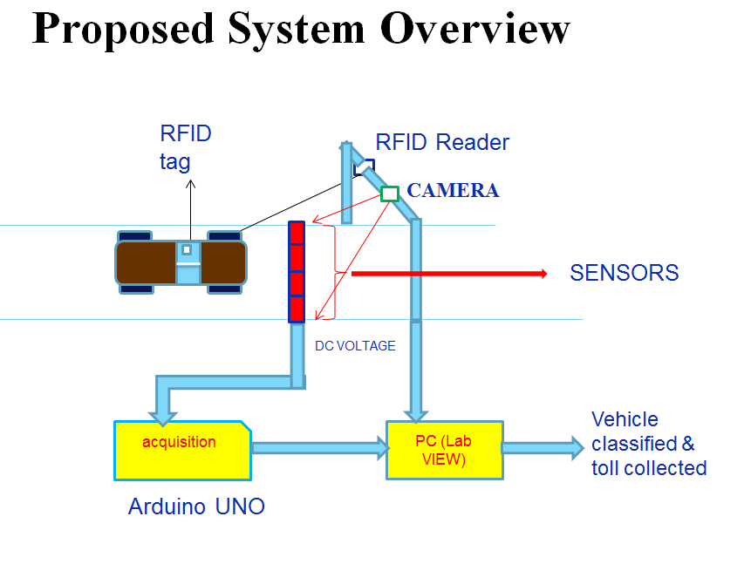

FIGS 1.1 BLOCK DIAGRAM OF VEHICLE CLASSIFICATION USING PIEZOELECTRIC SENSORS

**3.2 HARDWARE INTERFACING:**

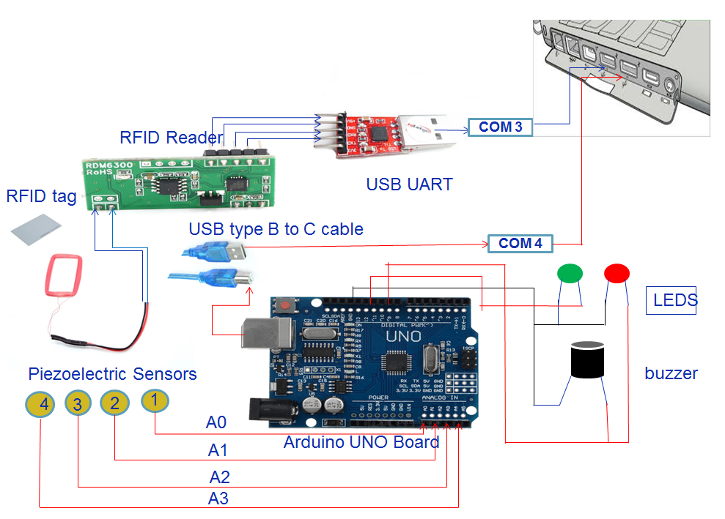**FIG 1.2** HARDWARE DESCRIPTION OF THE PROJECT

**3.3 SPECIFICATION OF THE PROJECT**

**3.3.1 FUNCTIONALITY:**

**Radio-Frequency Identification** (**RFID**) is the wireless use of electromagnetic fields to transfer data, for the purposes of automatically identifying and tracking tags attached to objects. The tags contain electronically stored information. Some tags are powered by electromagnetic induction from magnetic fields produced near the reader. Some types collect energy from the interrogating radio waves and act as a passive transponder.

**RFID Tags:**

RFID tags [8] contain at least two parts: an integrated circuit for storing and processing information, modulating and demodulating a radio-frequency (RF) signal, collecting DC power from the incident reader signal, and other specialized functions; and an antenna for receiving and transmitting the signal. The tag information is stored in a non-volatile memory. The RFID tag includes either a chip-wired logic or a programmed or programmable data processor for processing the transmission and sensor data, respectively. RFID tags [8] can be passive, active or battery-assisted passive. An active tag has an on-board battery and periodically transmits its ID signal. A battery-assisted passive (BAP) has a small battery on board and is activated when in the presence of an RFID reader. A passive tag is cheaper and smaller because it has no battery.

**RFID Readers:**

An RFID reader transmits an encoded radio signal to interrogate the tag. The RFID tag receives the message and then responds with its identification and other information. This may be only a unique tag serial number, or may be product-related information such as a stock number, lot or batch number, production date, or other specific information.

An **analog-to-digital converter** (**ADC**, **A/D**, or **A to D**) is used to convert the continuous physical quantity (usually voltage) into a digital number that represents the quantity's amplitude.

The conversion involves quantization of the input, so it necessarily introduces a small amount of error. Instead of doing a single conversion, an ADC often performs the conversions ("samples" the input) periodically. The result is a sequence of digital values that have been converted from a continuous-time and continuous-amplitude analog signal to a discrete-time and discrete-amplitude digital signal.

The digital signal that is produced by the ADC is stored in the battery. Then it is connected to the inverter which is used to convert the direct current into an alternating current. This produced alternating current is used in many ways, which is the main advantage of piezo electric sensors.

**3.3.2 Toll Rates:**

|  |  |  |
| --- | --- | --- |
| **Type of vehicle** | **Single Journey** | **Vehicle not Registered or Toll Violation** |
| **Bike** | **$10.00** | **$40.00** |
| **Car** | **$20.00** | **$40.00** |
| **Bus/Truck** | **$30.00** | **$40.00** |

**FIG 3.3.2 TOLL RATES**

**CHAPTER-4**

**HARDWARE AND SOFTWARE DESCRIPTION**

**4.1. Piezoelectric Sensors: [6]**



FIG-4.1 PIEZO ELECTRIC SENSOR WORKING

A **piezoelectric sensor** is a device that uses the piezoelectric effect, to measure changes in pressure, acceleration, strain or force by converting them to an electrical charge.

The piezoelectric effect is understood as the linear electromechanical interaction between the mechanical and the electrical state in crystalline materials with no inversion symmetry. The piezoelectric effect is a reversible process in that materials exhibiting the direct piezoelectric effect (the internal generation of electrical charge resulting from an applied mechanical force) also exhibit the reverse piezoelectric effect (the internal generation of a mechanical strain resulting from an applied electrical field). For example, lead zirconate titanate crystals will generate measurable piezoelectricity when their static structure is deformed by about 0.1% of the original dimension. Conversely, those same crystals will change about 0.1% of their static dimension when an external electric field is applied to the material. The inverse piezoelectric effect is used in production of ultrasonic sound waves.



FIG-4.2 WORKING OF PIEZOELECTRIC CRYSTAL.

In most crystals (such as metals), the unit cell (the basic repeating unit) is symmetrical; in piezoelectric crystals, it isn't. Normally, piezoelectric crystals are electrically neutral: the atoms inside them may not be symmetrically arranged, but their electrical charges are perfectly balanced: a positive charge in one place cancels out a negative charge nearby. However, if you squeeze or stretch a piezoelectric crystal, you deform the structure, pushing some of the atoms closer together or further apart, upsetting the balance of positive and negative, and causing net electrical charges to appear. This effect carries through the whole structure so net positive and negative charges appear on opposite, outer faces of the crystal.

The reverse-piezoelectric effect occurs in the opposite way. Put a voltage across a piezoelectric crystal and you're subjecting the atoms inside it to "electrical pressure." They have to move to rebalance themselves—and that's what causes piezoelectric crystals to deform (slightly change shape) when you put a voltage across them.

**4.2 ARDUINO UNO [7]:**

The Arduino UNO [7] is a microcontroller board based on the ATmega328 ([datasheet](http://www.atmel.com/dyn/resources/prod_documents/doc8161.pdf)). It has 14 digital input/output pins (of which 6 can be used as PWM outputs), 6 analog inputs, a 16 MHz ceramic resonator, a USB connection, a power jack, an ICSP header, and a reset button. It contains everything needed to support the microcontroller; simply connect it to a computer with a USB cable or power it with an AC-to-DC adapter or battery to get started.  
  
**4.2.2 Arduino Specifications:**

|  |  |
| --- | --- |
| **ARDUINO MICROCONTROLLER** | |
| Microcontroller | ATmega328 |
| Architecture | AVR |
| Operating Voltage | 5 V |
| Flash memory | 32 KB of which 0.5 KB used by boot loader |
| SRAM | 2 KB |
| Clock Speed | 16 MHz |
| Analog I/O Pins | 6 |
| EEPROM | 1 KB |
| DC Current per I/O Pins | 40 mA on I/O Pins; 50 mA on 3,3 V Pin |
| **GENERAL** | |
| Input Voltage | 7-12 V |
| Digital I/O Pins | 20 (of which 6 provide PWM output) |
| PWM Output | 6 |
| PCB Size | 53.4 x 68.6 mm |
| Weight | 25 g |
| Product Code | A000066 (TH); A000073 (SMD) |

The Arduino UNO [7] can be powered via the USB connection or with an external power supply. The power source is selected automatically.  
  
External (non-USB) power can come either from an AC-to-DC adapter (wall-wart) or battery. The adapter can be connected by plugging a 2.1mm center-positive plug into the board's power jack. Leads from a battery can be inserted in the Gnd and Vin pin headers of the POWER connector.  
  
The board can operate on an external supply of 6 to 20 volts. If supplied with less than 7V, however, the 5V pin may supply less than five volts and the board may be unstable. If using more than 12V, the voltage regulator may overheat and damage the board. The recommended range is 7 to 12 volts.  
  
The power pins are as follows:

Vin. The input voltage to the Arduino board when it's using an external power source (as opposed to 5 volts from the USB connection or other regulated power source). You can supply voltage through this pin, or, if supplying voltage via the power jack, access it through this pin.5V.This pin outputs a regulated 5V from the regulator on the board.

The board can be supplied with power either from the DC power jack (7 - 12V), the USB connector (5V), or the VIN pin of the board (7-12V). Supplying voltage via the 5V or 3.3V pins bypasses the regulator, and can damage your board. We don't advise it.3V3. A 3.3 volt supply generated by the on-board regulator. Maximum current draw is 50 mA. GND. Ground pins. IOREF. This pin on the Arduino board provides the voltage reference with which the microcontroller operates. A properly configured shield can read the IOREF pin voltage and select the appropriate power source or enable voltage translators on the outputs for working with the 5V or 3.3V.

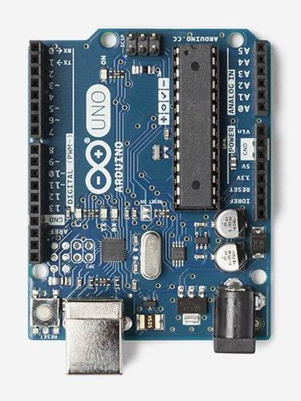

**FIG 4.3 ARDUINO UNO MODULE**

**4.3 Radio Frequency Identification (RFID) [8]:**

RFID systems consist of an antenna and a transceiver which read the radio frequency and transfer the information to a processing device and a transponder or tag which an integrated circuit is containing the circuitry and information to be transmitted. The RFID device serves the same purpose as a bar code or a magnetic strip on the back of a credit card or ATM card; it provides a unique identifier for that object. And, just as a bar code or magnetic strip must be scanned to get the information, the RFID device must be scanned to retrieve the identifying information.

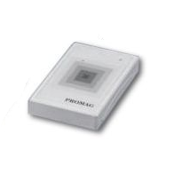

FIG-4.4 RFID READER

The RFID reader generates an electro-magnetic field which induces a current into the tag’s antenna. The current is used to power the chip. In passive tags the current also charges a condenser which assures uninterrupted power for the chip. In active tags a battery replaces the condenser. Once activated the tag receives commands from the reading unit and replies by sending its serial number or the requested information. In general the tag does not have enough energy to create its own electro-magnetic field, instead it uses back scattering to modulate the field sent by the reading of tags in presence of those materials is complicated. Every RFID tag consists of a unique number, as the tag comes close to the RFID reader the reader reads the number in the tag and process further.

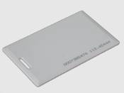

FIG-4.5 RFID TAG

RFID works better than Barcodes. A significant advantage of RFID devices over the others mentioned above is that the RFID device does not need to be positioned precisely relative to the scanner. We are all familiar with the difficulty that store checkout clerks sometimes have in making sure that a barcode can be read. And obviously, credit cards and ATM cards must be swiped through a special reader.

RFID technology has been available for more than fifty years. It has only been recently that the ability to manufacture the RFID devices has fallen to the point where they can be used as a “throwaway” inventory or control device. One reason that it has taken so long for RFID to come into common use is the lack of standards in the industry.

Some common problems with RFID are reader collision and tag collision. Reader collision occurs when the signals from two or more readers overlap. The tag is unable to respond to simultaneous queries. Systems must be carefully set up to avoid this problem.

**4.4 USB UART:**

This is a USB to Serial UART (TTL level) converter module. It is allow you to connect your computer through USB port and use it as a regular serial communication. All USB protocol is handled within the module. There is no other device or programming required.  
  
This board features innovations that set it apart from other USB to Serial Converter boards. Innovations feature like 256 byte receive buffer and 128 byte transmit buffer utilize new buffer smoothing technology to allow for high data throughput. Also, 6MHz clock output signal options for driving external MCU or FPGA. The TX and RX pins from the USB-SER can be connected directly to RX and TX pins of your preferred microcontroller or serial application for a simple serial cable replacement connection.

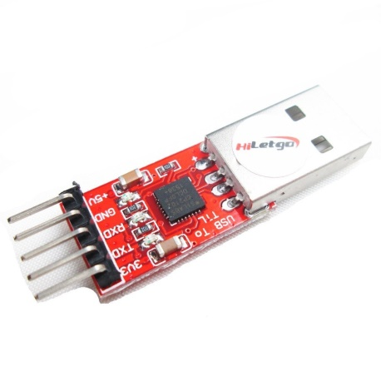

FIG 4.6 USB UART TTL MODULE

**4.5 LabVIEW [16]:**

LabVIEW [16] (Laboratory Virtual Instrument Engineering Workbench) is a graphical programming environment which has become prevalent throughout research labs, academia and industry. It is a powerful and versatile analysis and instrumentation software system for measurement and automation. Its graphical programming language called G programming is performed using a graphical block diagram that compiles into machine code and eliminates a lot of the syntactical details. LabVIEW offers more flexibility than standard laboratory instruments because it is software based. Using LabVIEW, the user can originate exactly the type of virtual instrument needed and programmers can easily view and modify data or control inputs.

LabVIEW programs are called virtual instruments (VIs), because their appearance and operation imitate physical instruments like oscilloscopes. LabVIEW is designed to facilitate data collection and analysis, as well as offers numerous display options. With data collection, analysis and display combined in a flexible programming environment, the desktop computer functions as a dedicated measurement device. LabVIEW contains a comprehensive set of Vis and functions acquiring, analysing, displaying and storing data, as well as tools to help you troubleshoot your code.

LabVIEW consists of two main parts

1. Front Panel.
2. Block Diagram.

**4.5.1 Front Panel [17]:**

The front panel is the interactive user interface for the VI. It is named a front panel because it stimulates the front panel of a physical instrument. Build the front panel with controls and indicators as shown in Figure-4.6.

The front panel include knobs, push buttons, graphs and various other controls (which are user inputs) and indicators (which are program outputs). Controls are inputs used to simulate instrument input devices and supply data to the block diagram of the VI, and indicators are outputs displays used to simulate instrument output devices and display data the block diagram acquires or generates. The front panel is customized to emulate control panels of traditional instruments create custom test panels or visually represent the control and operation of processes.



FIG-4.7 LabVIEW Front Panel

**4.5.2 Block Diagram:**

After you build the front panel, you add code using graphical representations of functions to control the front panel objects. The block diagram contains this graphical source code. Front panel objects appear as terminals on the block diagram. You cannot delete a terminal from the block diagram. The terminal disappears only after you delete its corresponding object on the front panel. The block diagram is the actual executable program as shown in Figure-4.7. The components of a block diagram are lower-level Vis, built-in functions, constants and program execution control structures. Wires have to be drawn to connect the corresponding objects together to indicate the flow of data between each of the.



FIG-4.8 LabVIEW Block Diagram

**4.5.3 Controls and Functions palettes:**

The Controls and Functions palettes contain sub palettes of objects you can use to create a VI. The controls palette is obtained in Front Panel and Functions palette is obtained in Block Diagram as shown in figure.

 

FIG-4.9 Controls and Functions Palettes in LabVIEW

**4.5.4 Loops and Structures:**

Loops are used to perform an action frequently with variations in the details each time. LabVIEW consists of FOR loop and WHILE loop. These loops are used to control repetitive operations. A while loop executes a sub diagram until a condition is met. A while loop stops executing the sub diagram, only if the expected value at the conditional terminal exists.

Structures are graphical representations of the loops and case statements of text-based programming languages. There are cases when a decision must be made in a program. In text-based programs this can be accomplished with statements like if-else, case and so on. LabVIEW includes many different ways of making decisions. It contains multiple sub diagrams, only one of which executes depending on the input value passed to the structure.



FIG-4.10 While Loop and Case Structure

**4.5.5 LabVIEW Program:**

The program that is used in this project is shown below. Front Panel is show in Figure 4.11 and Block Diagram is shown in Figure 4.12. The tools that are used in designing the program such as While loop, Case Structure, DAQ Assistant are explained above.

The program works as follows: when the vehicle passes over the sensor stream with RFID tag one of the BUS, CAR or BIKE LED will glow. If the information in the RFID tag represents the vehicle type (BUS, CAR, BIKE) then it will check this with the output obtained from LEDs, it both are same then one of the Bus confirm, Sedan confirm, LUV confirm LED will glow.

**4.5.6 LabVIEW Interfacing for Arduino [9]:**

* In order to interface LabVIEW with Arduino we have to dump the LIFA Base code in Arduino.
* We can download the LIFA Base [9] from NATIONAL INSTRUMENTS website.
* We can dump LIFA Base code in Arduino board [9] using Arduino software.

**4.5.7 SOFTWARE PROGRAM AND DESCRIPTION:**

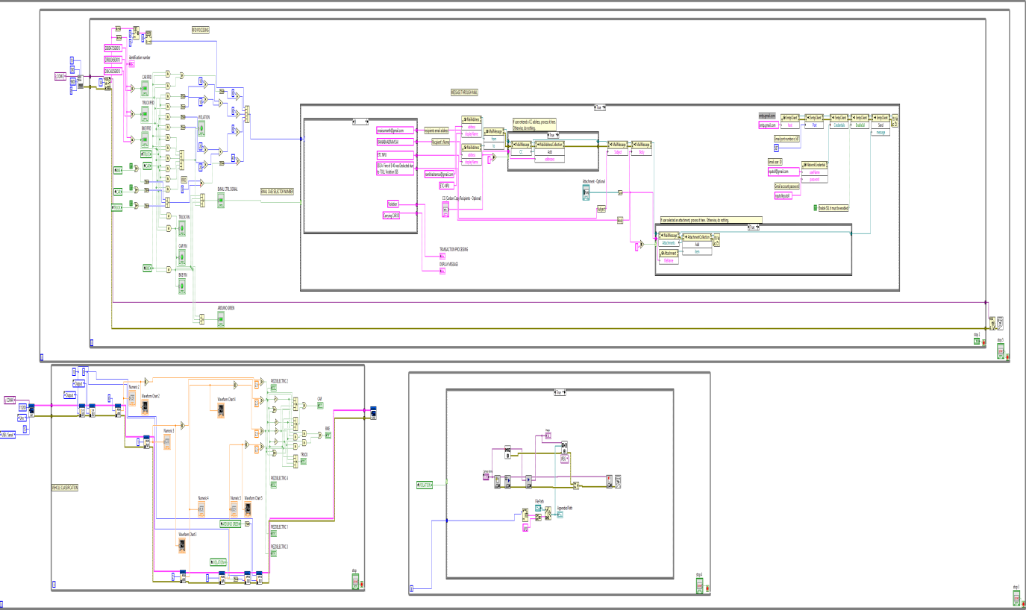

FIG 4.11 Block Diagram of the Project

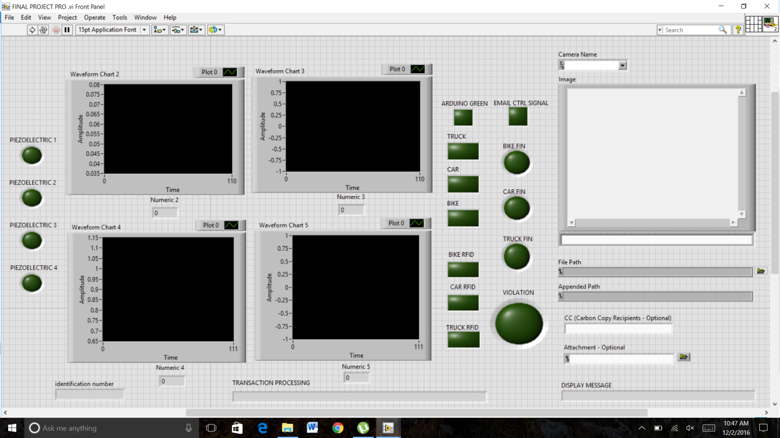

FIG 4.12.1 Front Panel of the Project

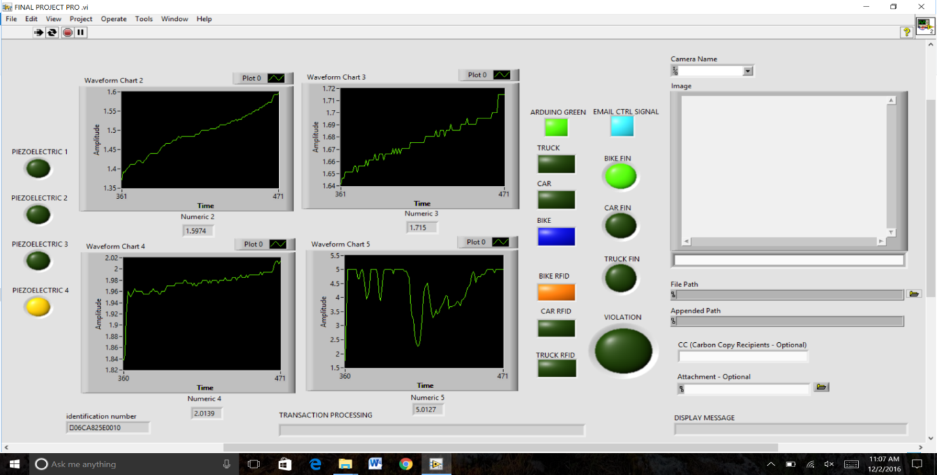

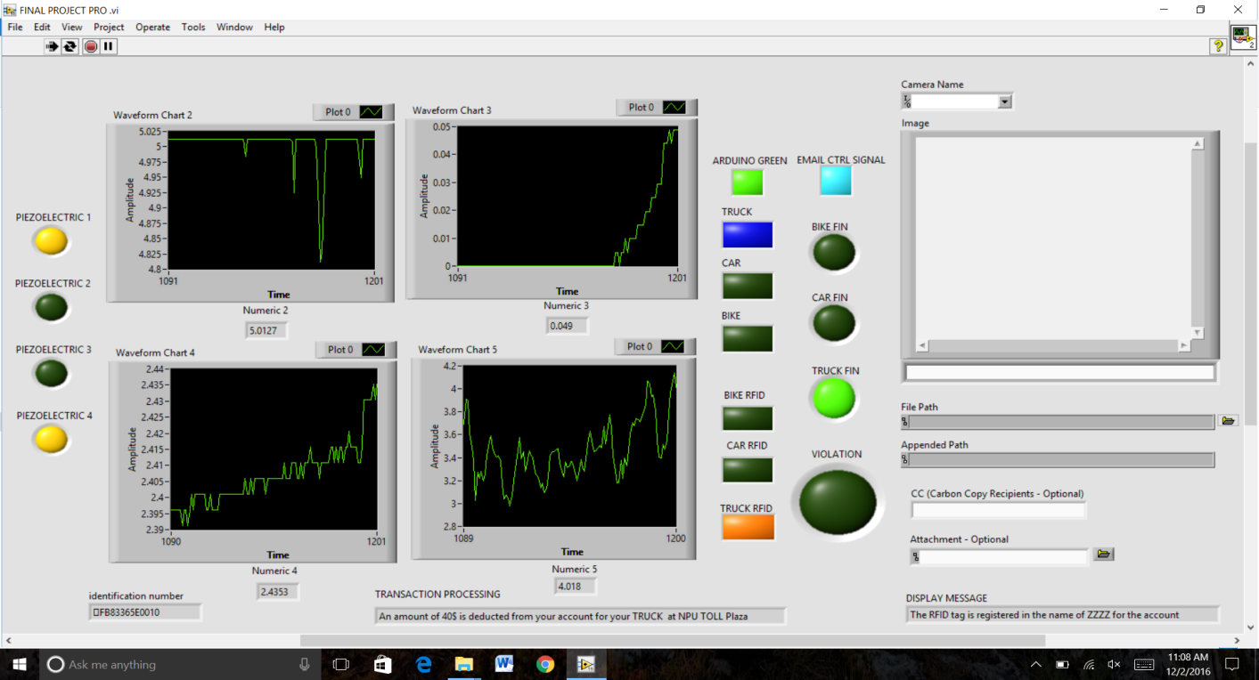

FIG 4.12.3 Front Panel of the Project

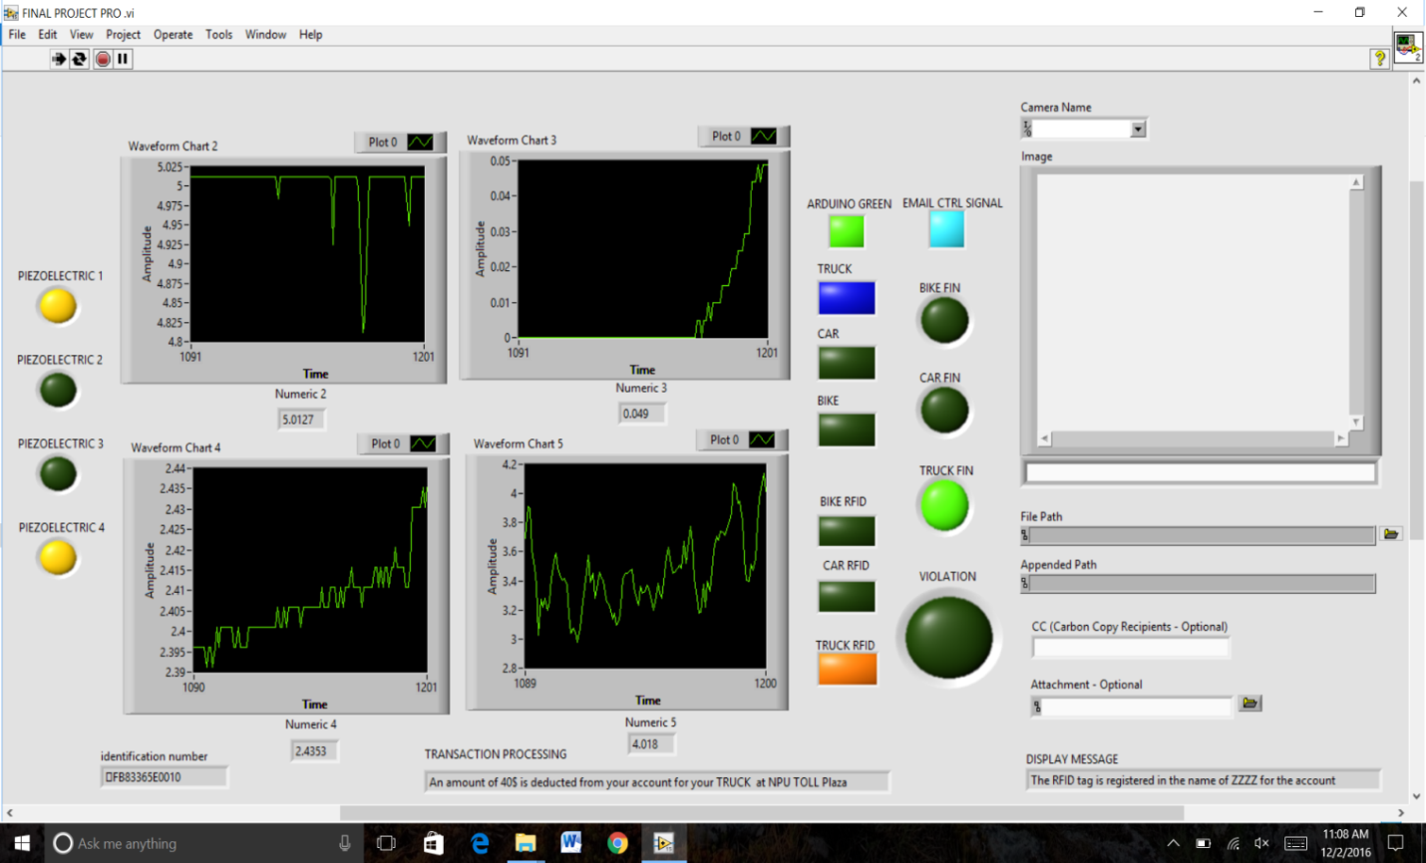

FIG 4.12.4 Front Panel of the Project

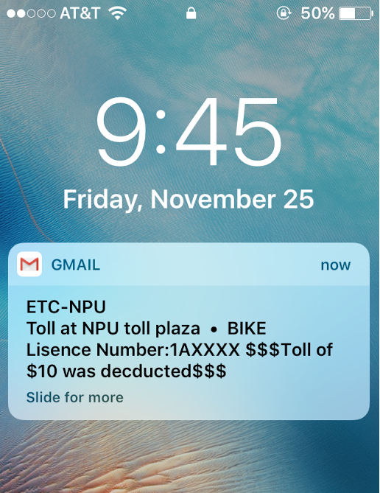 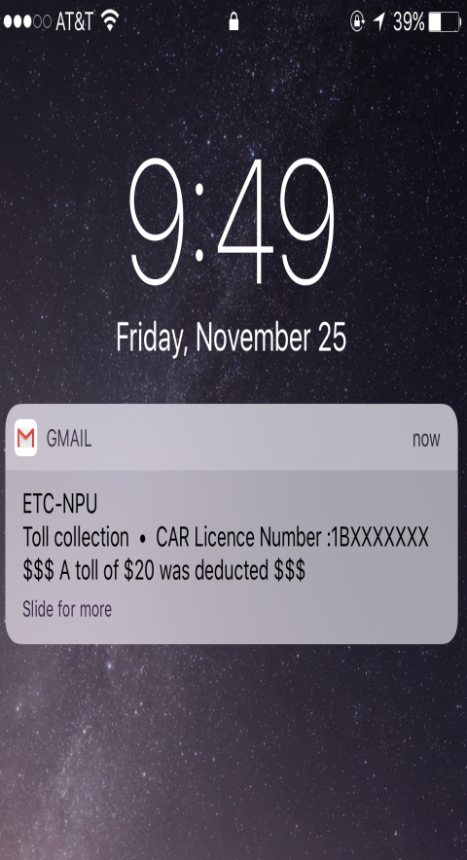 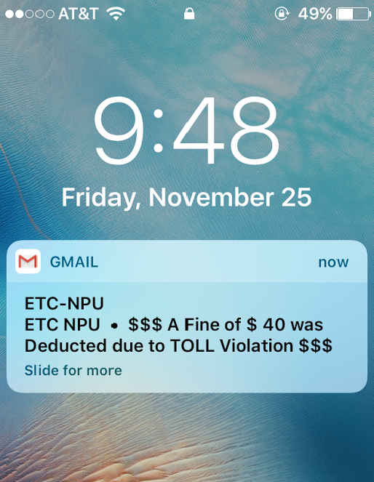

FIG 4.12.4 Message Received to mail of the desired vehicle owner

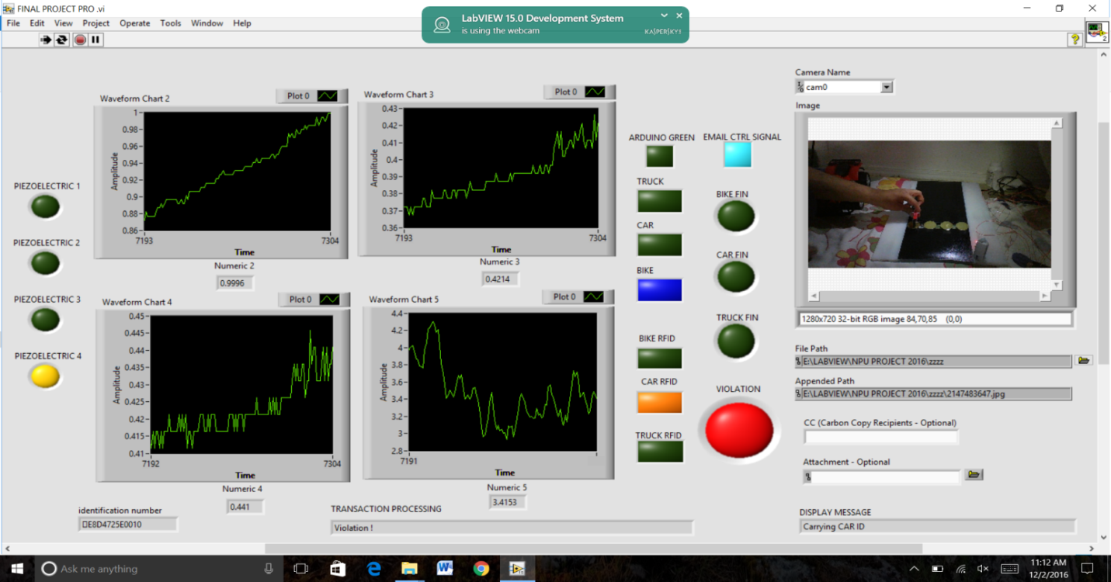

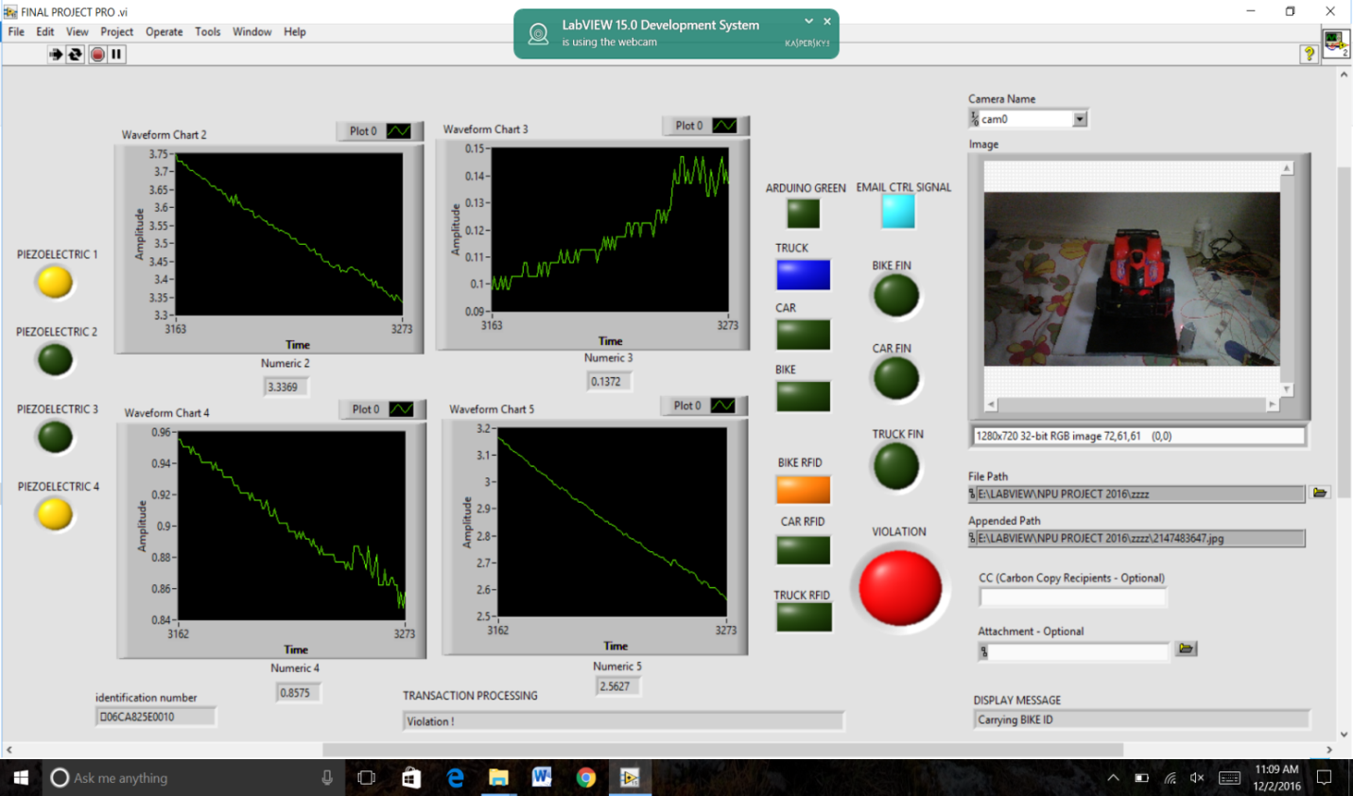

**CHAPTER-5**

FIG 4.12.1 Front Panel during violated vehicles

**CHAPTER-6**

**FUTURE WORK AND CHALLENGES**

This project needs constant care and attention in defining the threshold values for classifying vehicles. Any slight distraction in accuracy while defining these values would cause erroneous results. Furthermore, the velocity of the vehicles and the loading of the vehicles should be taken into account while defining the threshold values.

Low end piezoelectric sensors have very low power producing capabilities (say in micros). Piezoelectric sensors should be chosen depending upon the end application which the user wants to run using this power generated. Moreover, for high efficiency rates high end piezoelectric sensors should be used, which is a costly affair.

Piezoelectric sensors are subjected to wear and tear when used for certain period of time. Moreover, in this context we use very high load vehicles like lorry, tractors which might easily destroy the sensors. This will defeat our initial idea to produce an economical, robust and durable vehicle classification system.

This proposal requires the vehicles to move in a slow and steady manner i.e., the vehicles need to go below a pre-defined speed. This is in serious conflict of E-tolls idea, since this restricts the speed of motorists and may cause dissatisfaction among toll payers.

We have chosen two different approaches to produce an efficient output. One of them can be chosen to implement the project. The second approach can be used as a feedback system to increase the efficiency rates.

**CHAPTER-7**

**CONCLUSION**

Highways being the lifeline of any economy, the congestion and dis-comfort in paying fees should be avoided as far as possible. Given the idea of expansion plan and congestion control for National Highways, there is an underlying need to delve into manual method of toll collection. Considering user convenience, rate of acceptance and ease of implementation, we try to improve the way toll fees are collected by introducing Electronic Toll Collection System. To make this system more beneficial and efficient we need to introduce a more durable, efficient and robust vehicle classification system.

On the flip side, we try to utilise the mechanical energy produced by the vehicles due to the stress on the roads. This mechanical energy is converted into electrical energy by using piezoelectric sensors. Piezoelectric sensors convert the stress applied on it to dc voltage. We define threshold values to this dc voltage produced to provide vehicle classification. This not only provides an efficient vehicle classification system but also provides an unconventional source of energy from an often unheeded source.

**CHAPTER-6**

**RFERENCES**

1) “Electronic Toll Collection System”, <http://en.wikipedia.org/wiki/Electronic_toll_collection>

2) “Apex Committee Survey Report on Statistics of Electronic Toll Collection System”, <http://www.nhai.org/doc/17feb12/etc_apexcomm_report_final_7oct.pdf>

3)Design and Evaluation of a Robust Optical Beam-Interruption-Based Vehicle Classifier System

4) The Lane with in US highways

<http://ops.fhwa.dot.gov/publications/fhwahop10023/chap4.htm>

5) Ford cars front axil with distance for different cars [http://diyford.com/ford-axle-history-identification-ford-differentials/#](http://diyford.com/ford-axle-history-identification-ford-differentials/).

6) Piezoelectricity definition <http://www.explainthatstuff.com/piezoelectricity.html>

7) Arduino UNO kit description <https://www.arduino.cc/en/Main/ArduinoBoardUno>

8) RFID Tags working http:http://www.engineersgarage.com/insight/how-rfid-tag-works?page=2

9) LabVIEW Interface with Arduino code <https://decibel.ni.com/content/docs/DOC-30365>

10) Saowaluck Kaewkamnerd; Chinrungrueng, J. Pongthornseri, R., Dumnin, S., “Vehicle Classification Based on Magnetic Sensor Signal,” Proceedings of the 2010 IEEE International Conference on Information and Automation, June 2010.

11)Sroka, R., “Data fusion methods based on fuzzy measures in vehicle classification process,” 21st IEEE Instrumentation and measurement Technology Conference, May 2004.

12)Carlos Sun; Akoum, A.H. Chauvet, P, “Inductive Classifying Artificial Network for Vehicle Type Categorization,” Computer-Aided Civil and Infrastructure Engineering, 2003.

13) Janus Gajda; Sroka, R.Stencel, M. Wajda, A Zeglen, T., “A Vehicle Classification Based on Inductive Loop Detectors”, IEEE Instrumentation and Measurement Technology Conference, 2001

14) Wikipedia notes on piezoelectric sensors www.wikipedia.com/piezoelectricsensors

15) National Instruments user manual for equipment. [www.decibel.ni.com/](http://www.decibel.ni.com/)

16) NIYANTRA training sessions – LABVIEW overview.

17) National Instrument user manual for equipment

[http://www.ni.com/pdf/manuals/374707e.pdf{NI-9225,fig](http://www.ni.com/pdf/manuals/374707e.pdf%7bNI-9225,fig) }